- TestRail

TestRail Account Creation:

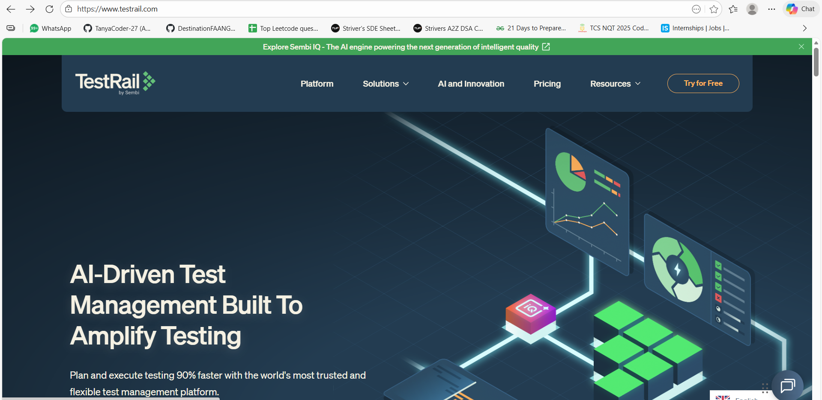

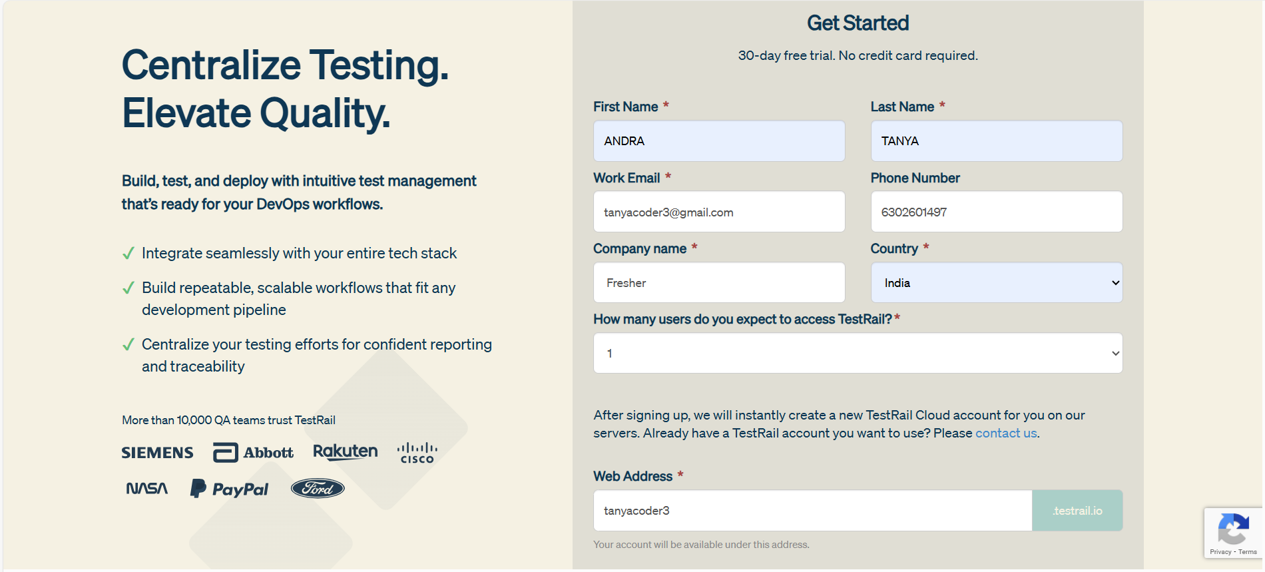

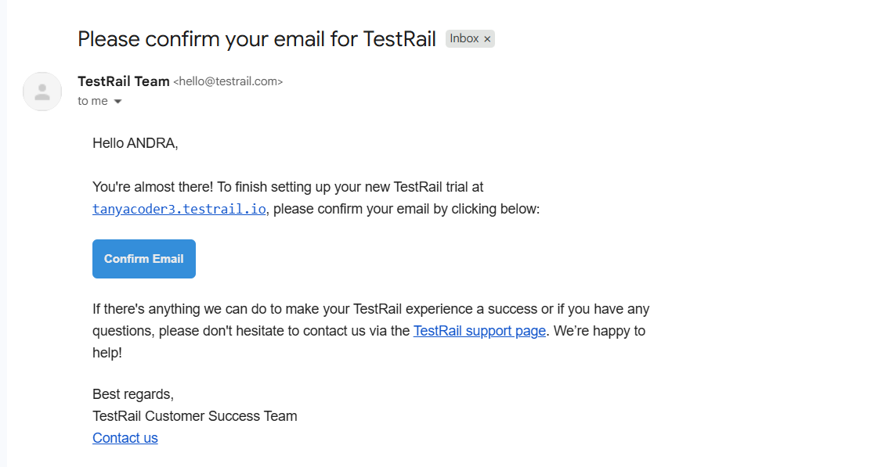

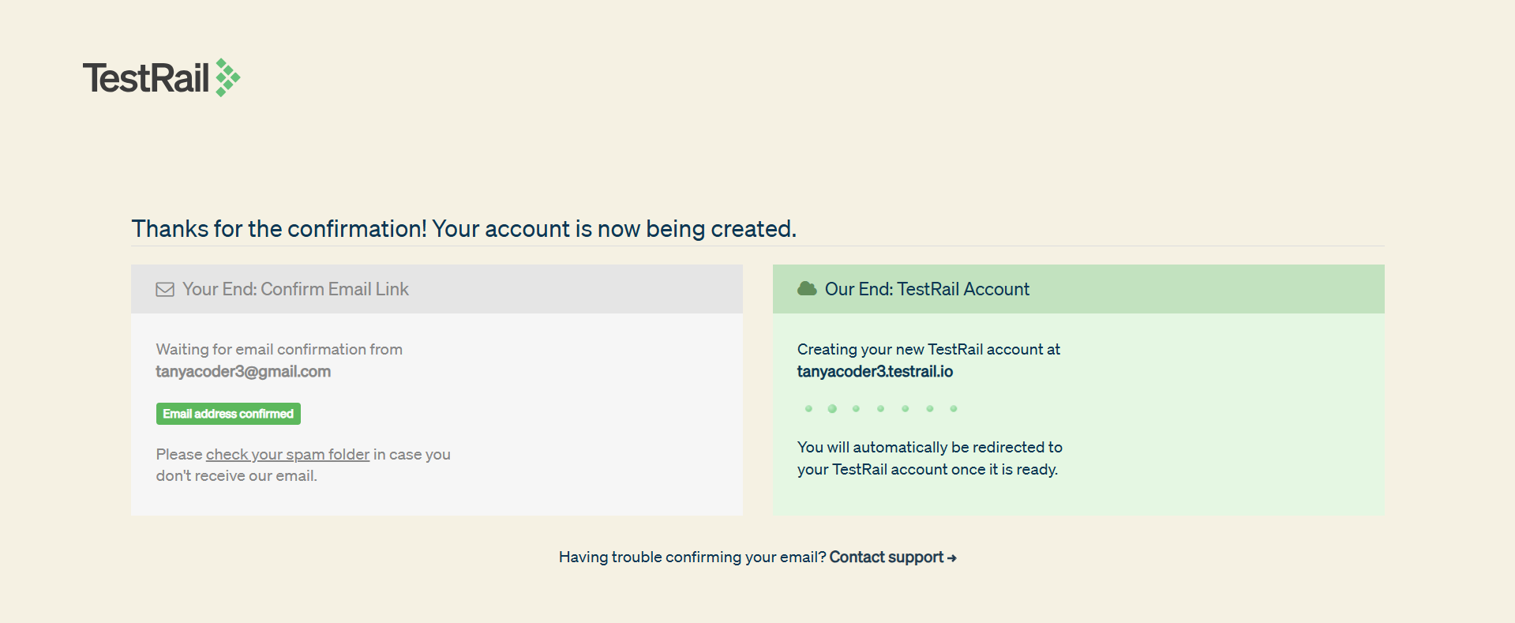

Add Project in TestRail:

I practiced basic project creation in TestRail to understand how testing work is organized. After logging in, I explored the Dashboard, which shows all projects, recent testing activity, and quick links to test cases, test runs, milestones, and reports. This page helps in getting a quick overview of ongoing testing.
From the dashboard, I created a new project by giving a project name and adding a short announcement. I learned that a project in TestRail represents testing for a particular application or system, and announcements are used to share important information with the team.
While creating the project, I selected the single repository option for test cases. This keeps all test cases in one place and allows them to be reused across different test runs. This approach is commonly used in Agile projects because it is easy to manage and avoids duplication.
I also explored the options related to test case statuses and approvals. I understood that TestRail supports review and approval workflows to maintain test quality, especially in large or regulated projects. I am aware of these features, though I did not configure them in detail.
After saving, I verified that the project was successfully created and visible in the project list. Through this activity, I gained basic hands-on experience with the TestRail dashboard, project creation, and project-level configuration, along with an understanding of how TestRail is used to manage testing work.

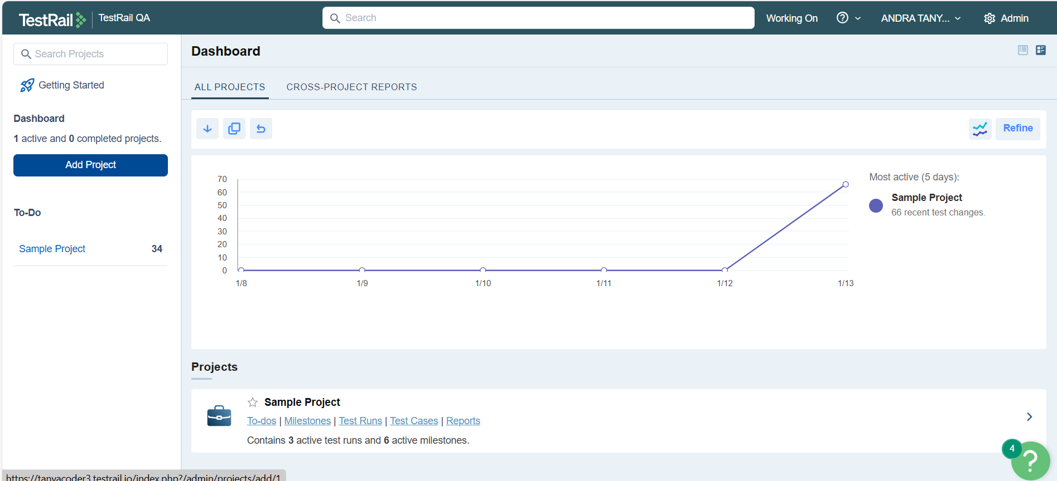

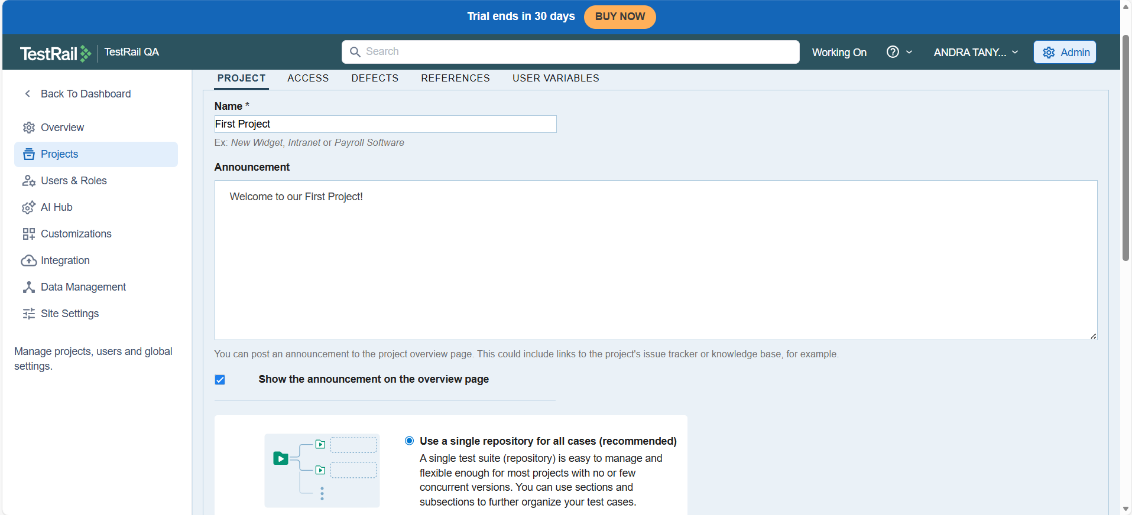

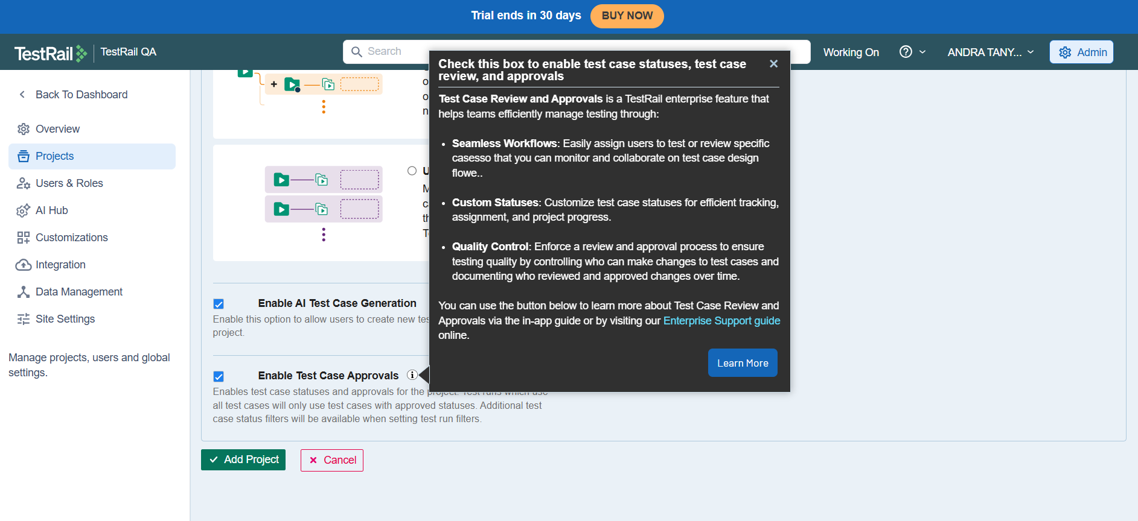

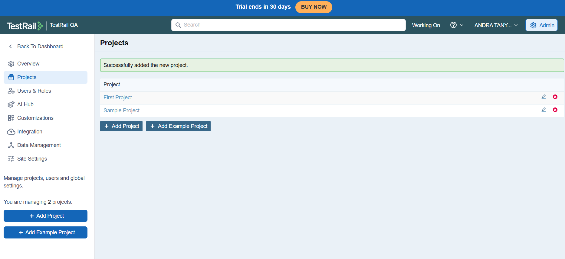

Project Options in TestRail:

While creating a project in TestRail, I learned that TestRail provides different project options to manage test cases based on the type of testing and project needs. These options mainly control how test cases are stored and organized within a project.
The first option is a project with a single repository for all test cases. This is the option I used while creating my project. In this setup, all test cases are stored in one central repository and can be reused across multiple test runs and milestones. This option is commonly used in Agile projects because it makes test case management simple and avoids duplication. Test cases are written once and executed many times as the application evolves, which is useful for regression and continuous testing.
The second option is a project with a single repository and baseline support. In this type, test cases are still stored in one central repository, but TestRail also allows maintaining baselines. Baselines are snapshots of test cases taken at a particular point in time, such as before a release. This helps in tracking how test cases change across versions and comparing older and newer versions of test cases. This option is mainly used in projects where version control, audits, or compliance tracking is important.
The third option is a project with multiple test suites to manage test cases. In this setup, test cases are divided into separate suites, and each suite acts as an independent repository. This approach is useful when different versions, products, or components need to be tested separately and test cases should not be reused across suites. However, this option is less commonly used in Agile projects because it can lead to duplication and higher maintenance effort.
Overall, I understood that the single repository option is the most commonly used and recommended approach for Agile and continuous testing, while baseline support and multiple test suites are selected based on specific project requirements such as compliance, version comparison, or strict separation of test cases.

Project Overview Page

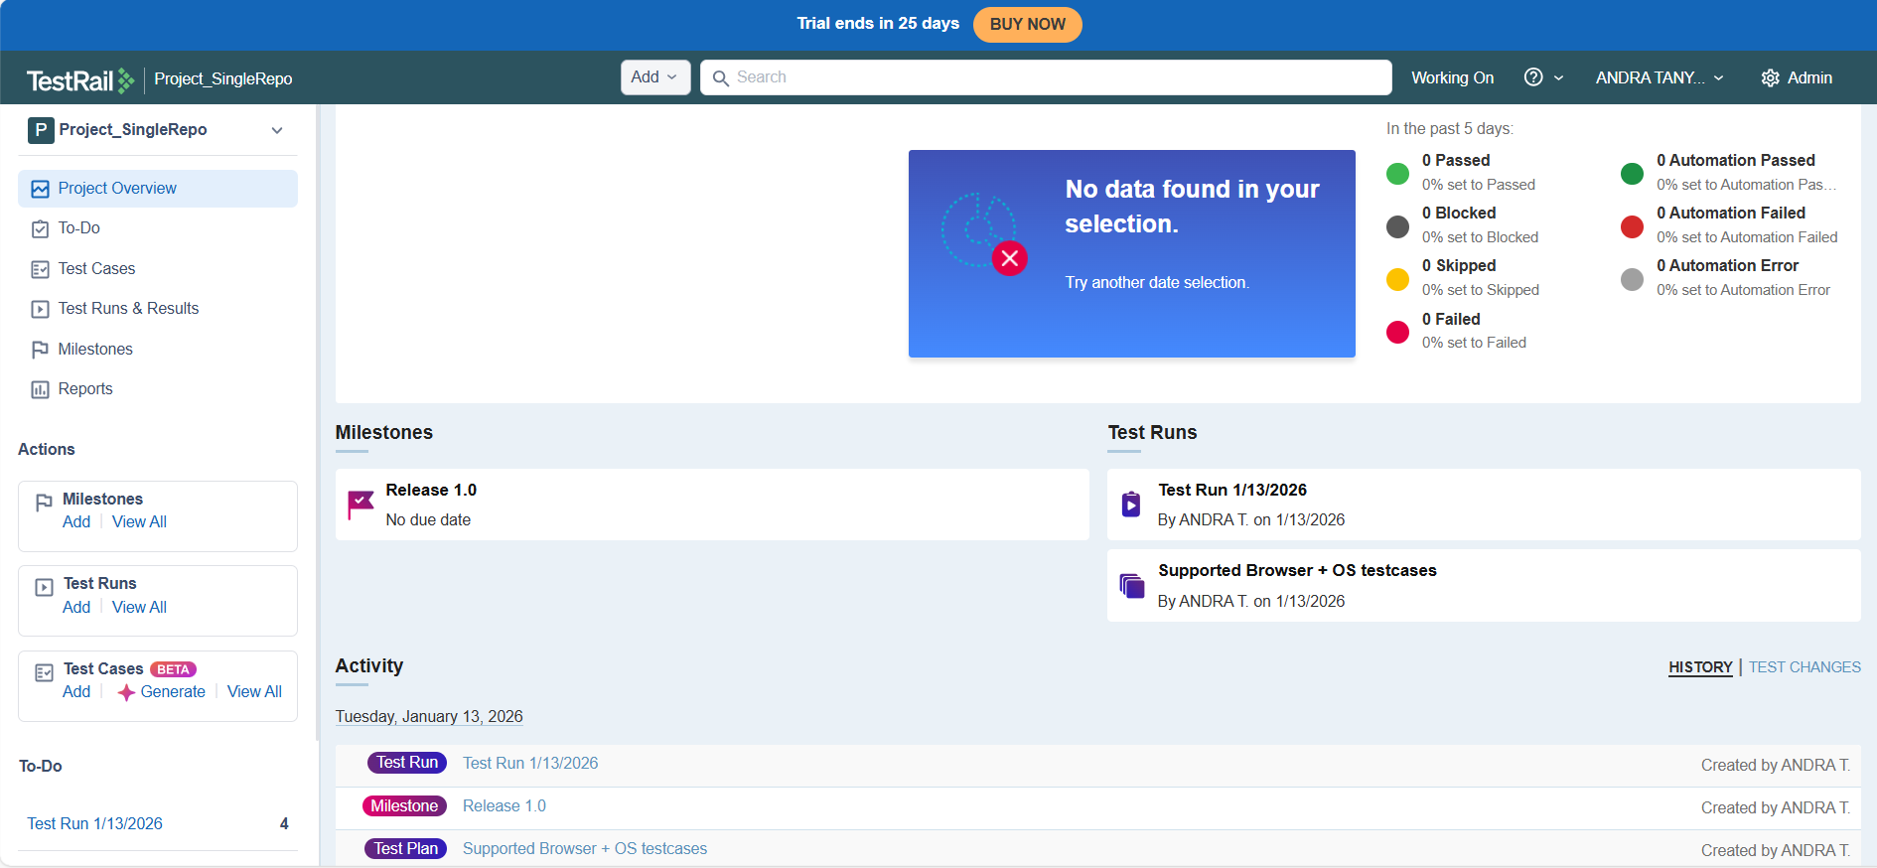

The Project Overview page in TestRail provides a high-level summary of the entire testing activity within a project. It is mainly used to quickly understand the current status of test execution, milestones, and recent activities without going into detailed sections.
From this page, I observed that the overall test execution status is displayed at the top, showing counts for passed, failed, blocked, skipped, and automation-related results for a selected time period. This helps in quickly understanding the health of the project. Since no tests were executed recently, the page currently shows no data for the selected date range.
The Milestones section gives visibility into planned or ongoing releases. In my project, the milestone named Release 1.0 is visible, which represents a version or phase of the application being tested. Milestones help in organizing test runs and tracking testing progress against a specific release.
The Test Runs section shows all the test runs created under the project. From this, I can directly access individual test runs and see when they were created and by whom. This makes it easy to monitor execution progress and revisit completed or ongoing runs.
The Activity section displays a timeline of recent actions such as creation of test runs, milestones, and test plans. This helps in tracking changes made to the project and understanding who performed what action and when.
Overall, I understood that the Project Overview page acts as a dashboard for the project, giving quick visibility into testing progress, execution status, milestones, and recent activity, which is useful for both testers and stakeholders to get a summary view of the project.

Adding Testcase in TestRail

I practiced adding test cases in TestRail to understand how individual test scenarios are created and managed within a project. From the Test Cases section of the project, I first created sections such as UI and Database to organize test cases based on application areas. Sections help in grouping related test cases and make the test repository easier to navigate and maintain.
Within a section, I added a new test case by providing a test case title and opening the detailed test case editor. Each test case in TestRail is assigned a unique ID automatically, which helps in tracking and referencing the test case across test runs, reports, and defect tracking tools.
While creating the test case, I observed several important fields that define the test case metadata. These include the section where the test case belongs, the template used for the test case, the test case type, priority, status, assigned user, and estimation. These fields help teams classify, prioritize, and plan testing activities effectively. I understood that keeping this information updated improves reporting and test management.
I also explored the different test case templates available in TestRail. The default template used was the Test Case (Text) template, which allows writing test steps and expected results in a simple text format. This template is commonly used for basic manual testing where detailed step-by-step execution is required.
Another template available is the Test Case (Steps) template. This template structures the test case into individual steps and expected results for each step. It is useful when test execution needs to be very clear and consistent, especially for complex test scenarios or when multiple testers are involved.
I also noticed the Behavior Driven Development (BDD) template. This template follows the Given-When-Then format and is mainly used in Agile teams where test cases are written in a business-readable language. It helps in aligning testing with business requirements and is often used along with automation frameworks.
Additionally, I saw the Exploratory Session template, which is used for exploratory testing. Instead of fixed steps, this template focuses on test mission, goals, and notes captured during testing. It is useful when testers want flexibility and want to explore the application without predefined steps.
While working on the test case editor, I also understood the purpose of fields like automation type and automation candidate. These fields are used to indicate whether a test case is automated or planned for automation in the future. This helps teams track automation coverage and plan automation efforts.
After saving the test case, I verified that it appeared correctly under the selected section and could be edited, deleted, or reused in test runs. Through this activity, I gained hands-on understanding of how to create, structure, and manage test cases in TestRail, along with awareness of different test case templates and their practical usage in real testing projects.

First of all, add sections for good categorization:
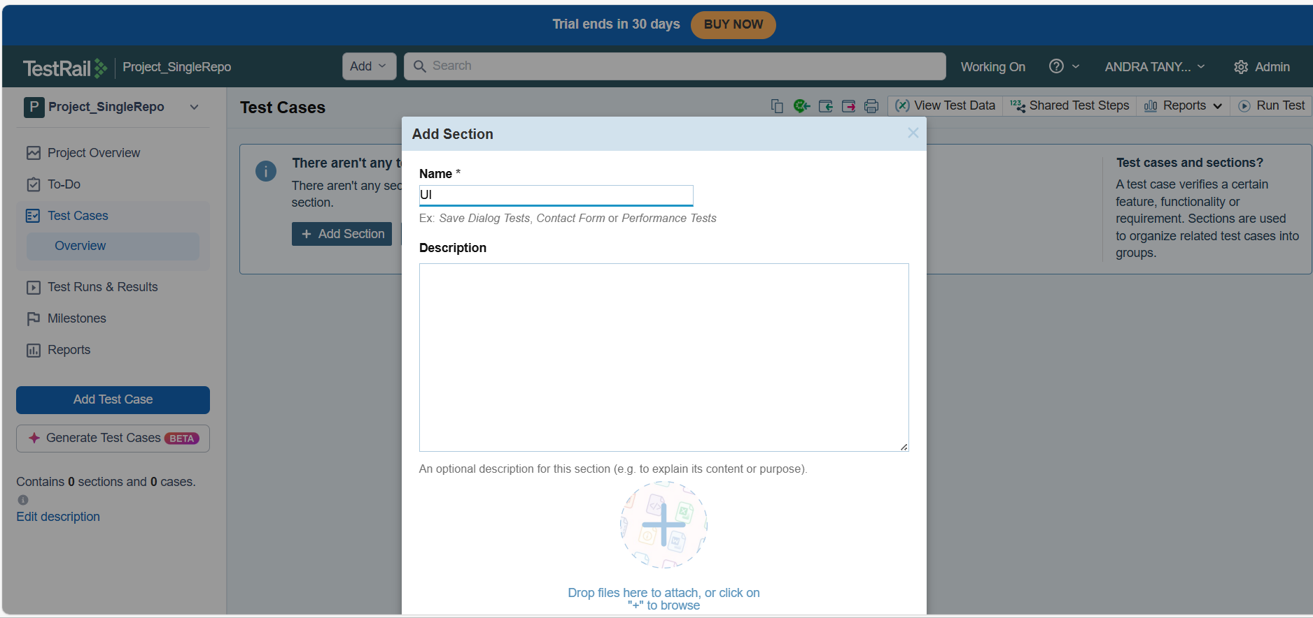

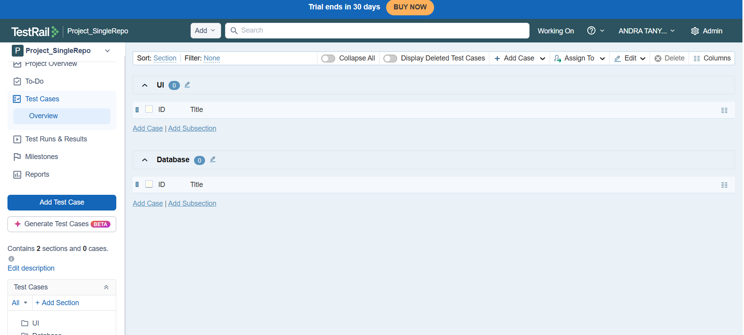

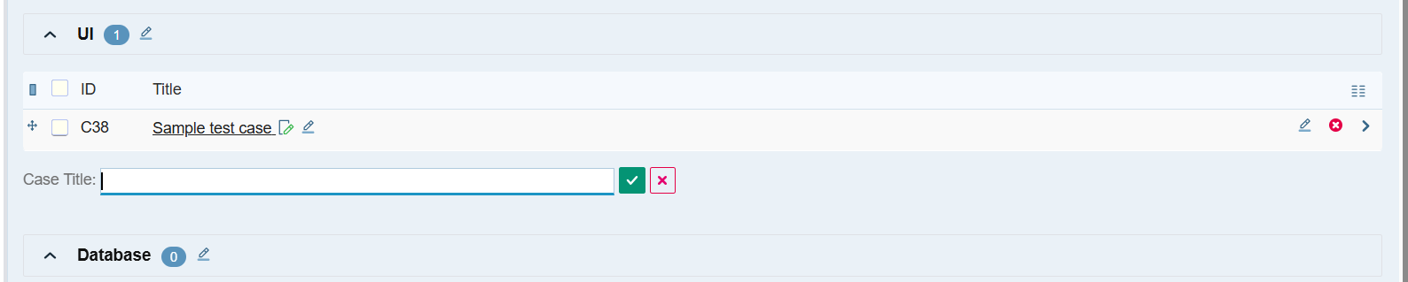



Types of Templates available in test case creation:

- Test Case (Text)
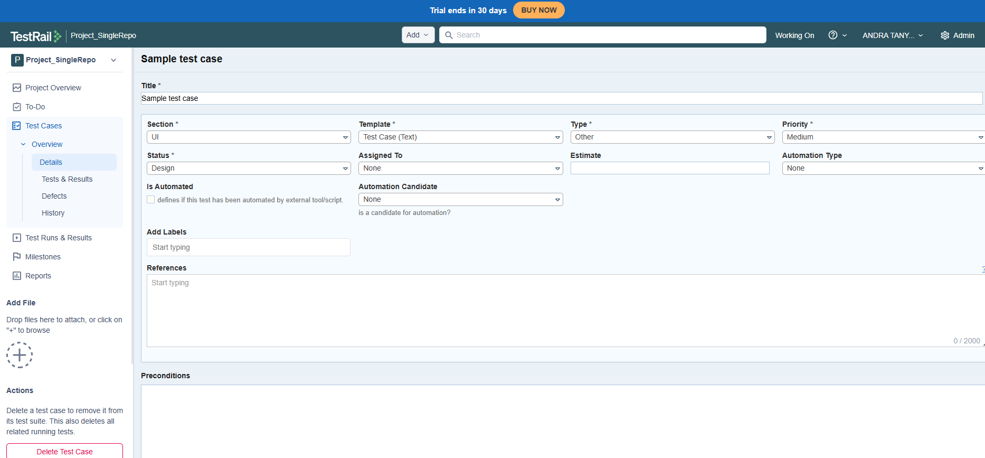

- TestCase (Steps)
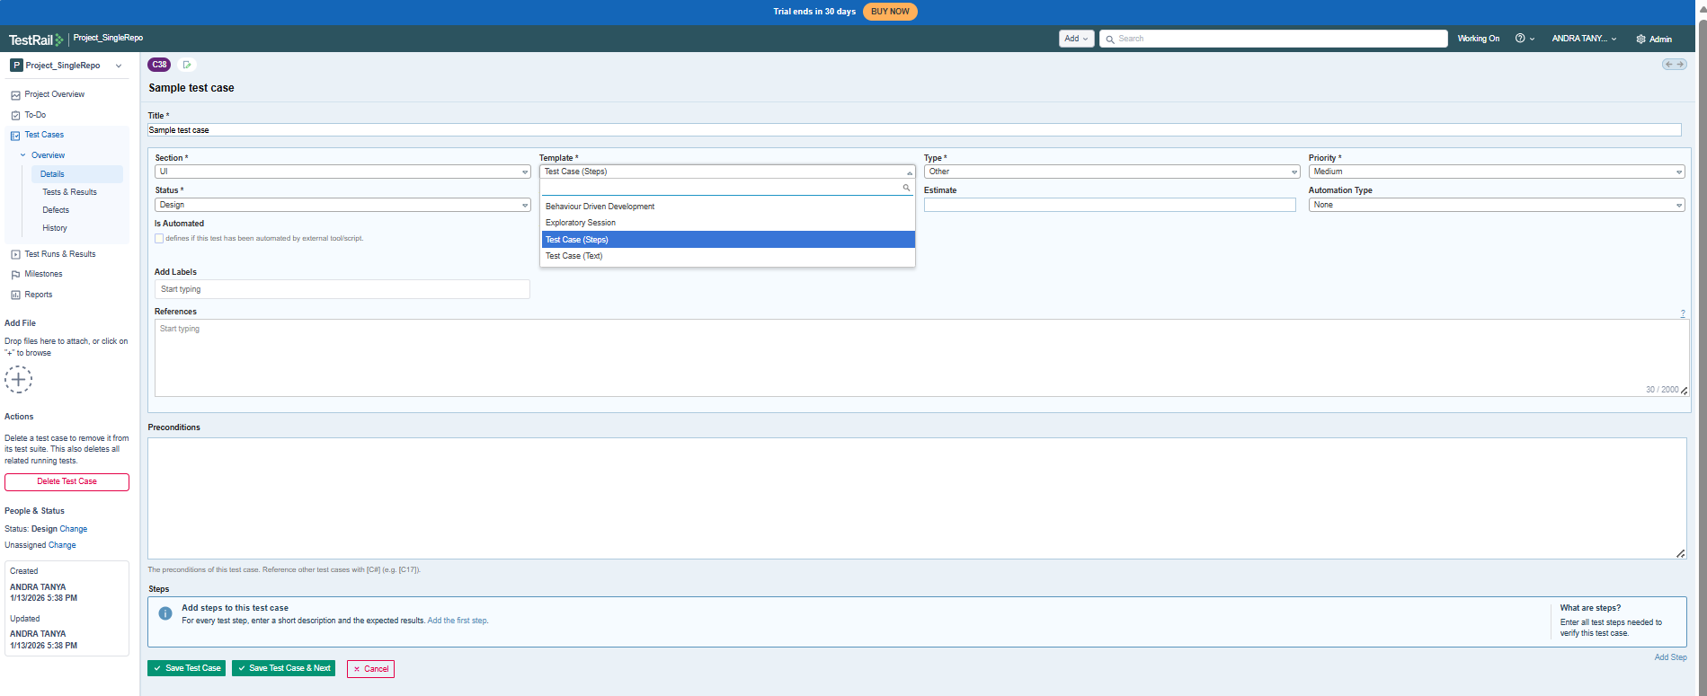

- Exploratory Session
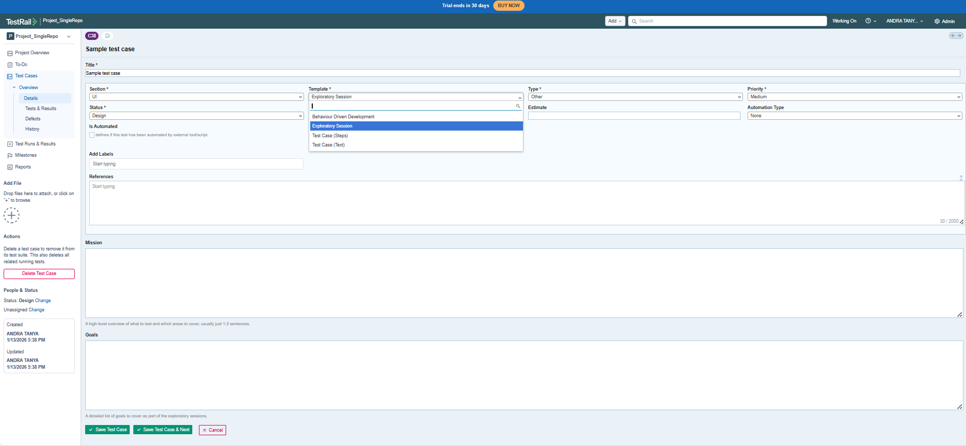

d)BDD – Behaviour Driven Development

Bulk editing Testcases in TestRail:
- I performed bulk editing of multiple test cases in TestRail to efficiently update common fields across selected records. From the Test Cases module, I selected multiple test cases using the checkbox option and accessed the Edit Selected action from the toolbar. This allowed me to apply changes to more than one test case in a single operation instead of modifying them individually.
- In the bulk edit screen, I updated key attributes such as Section and Priority for the selected test cases. The section was set to UI to organize the test cases under the appropriate functional area, and the priority was updated to Critical to highlight the business importance and execution urgency of these test scenarios.
- After configuring the required fields, I reviewed the changes in the Review Changes confirmation window. This step helped verify the exact modifications that would be applied to all selected test cases, ensuring accuracy before final submission. The review screen clearly displayed the old and new values for each updated field.
- Once the changes were confirmed, I executed the bulk update operation, and the system successfully applied the updates to all selected test cases. A success message was displayed, confirming that the operation was completed without errors.
- This practical exercise demonstrated how bulk editing improves productivity by reducing repetitive manual work, maintaining consistency across multiple test cases, and ensuring faster test case management within large test suites.

